**ICE 6**

id:7   
name: Harshil Patel

**objective**

1. Create lower-case node.
2. Create celsius-to-fahrenheit node.
3. Link Arduino with Node-RED with three LED lights.

**part 1 & 2**

in this part we have to create our own node for node-red to perform to different task 1) lower-case node( which was already giving ) 2) celsius-to-fahrenheit node( for which we have to write our own js file to create the node. 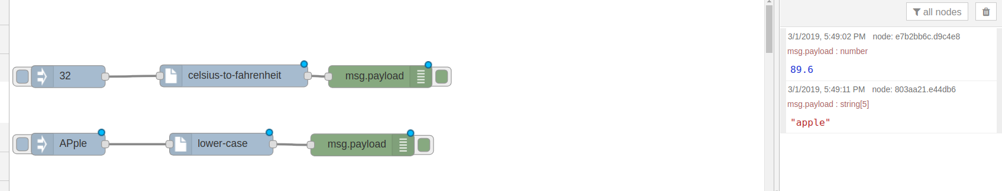

**part 3**

in this part we have to link the arduino to node-red on control the led light.  
for this part we need to install node-red-node-arduino using this command.  
  
**npm install node-red-node-arduino**   
  
after that we have write node function to control three led using node-red.  
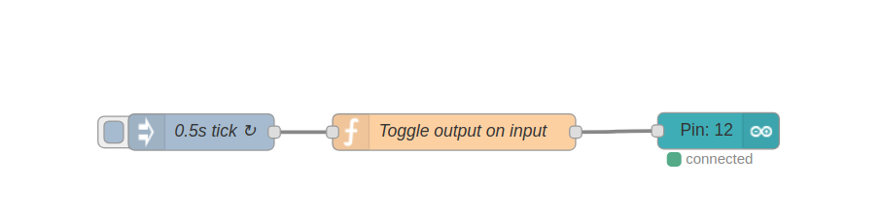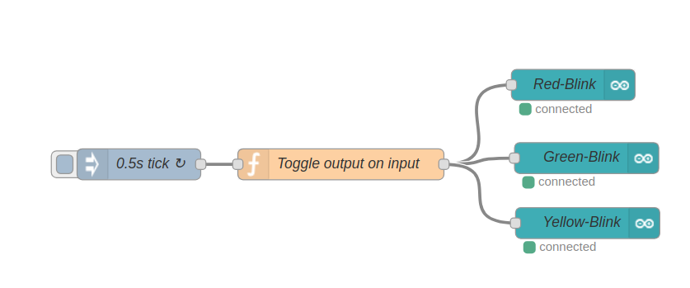

**conclusion**

with the help of this assignment we where able to learn...

1. create costume node function in node-red.
2. link arduino with node-red.